 | Numbots | Maths  Oak Academy | English  Oak Academy | Wider Curriculum  Oak Academy | Study Ladder  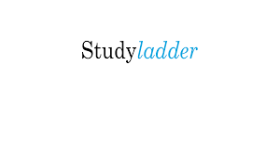 | Spellings  And Home Learning  Projects
Monday | Numbots | Multiplication and Division | English | History | Studyladder | Please practise the weekly spelling tasks and complete the project tasks that were sent home at the beginning of Autumn 2.
Tuesday | Numbots | Multiplication and Division | English | History | Studyladder | Please practise the weekly spelling tasks and complete the project tasks that were sent home at the beginning of Autumn 2.
Wednesday | Numbots | Multiplication and Division | English | History | Studyladder | Please practise the weekly spelling tasks and complete the project tasks that were sent home at the beginning of Autumn 2.
Thursday | Numbots | Multiplication and Division | English | History | Studyladder | Please practise the weekly spelling tasks and complete the project tasks that were sent home at the beginning of Autumn 2.
Friday | Numbots | Multiplication and Division | English | History | Studyladder | Please practise the weekly spelling tasks and complete the project tasks that were sent home at the beginning of Autumn 2.

YEAR 2 REMOTE LEARNING 5.1.2021

